**Report on Pet Classification Model Using CNN**

**Name: Ryne Mascarenhas**

**Email id: rynem8@gmail.com**

**Content Page**

**1. Introduction**

**2. Code Structure**

**3. Observations**

**3.1 Data Augmentation**

**3.2 Model Architecture**

**3.3 Training and Evaluation**

**3.4 Predictions**

**3.5 Visualization**

**5. Conclusion**

1. **Introduction: Pet Classification Model Using CNN**

The following report is based on the following:

**Project Objective:**  
Build a CNN model that classifies the given pet images correctly into dog and cat images.   
The project scope document specifies the requirements for the project “Pet Classification Model Using CNN.” Apart from specifying the functional and non-functional requirements for the project, it also serves as an input for project scoping.

**Project Description and Scope:**  
You are provided with a collection of images of pets, that is, cats and dogs. These images are of different sizes with varied lighting conditions, and they should be used as inputs for your model.

You are expected to write the code for CNN image classification model using TensorFlow that trains on the data and calculates the accuracy score on the test data.

**Project Guidelines:**  
Begin by creating the ipynb file in the same parent folder where the downloaded data set is kept. The CNN model should have the following layers:   
● Input layer   
● Convolutional layer 1 with 32 filters of kernel size[5,5]   
● Pooling layer 1 with pool size[2,2] and stride 2   
● Convolutional layer 2 with 64 filters of kernel size[5,5]   
● Pooling layer 2 with pool size[2,2] and stride 2   
● Dense layer whose output size is fixed in the hyper parameter: fc_size=32   
● Dropout layer with dropout probability 0.4   
Predict the class by doing a SoftMax on the output of the dropout layers.   
This should be followed by training and evaluation:   
● For the training step, define the loss function and minimize it   
● For the evaluation step, calculate the accuracy   
Run the program for 100, 200, and 300 iterations, respectively. Follow this by a report on the final accuracy and loss on the evaluation data.

The given code implements a Convolutional Neural Network (CNN) for image classification using TensorFlow and Keras. This type of neural network is particularly effective in image-related tasks due to its ability to capture spatial hierarchies and patterns.

1. **Code Structure**

The following code is written in visual studio code and interpreted in a conda virtual environment. The virtual environment is built on python 3.10 and installed with TensorFlow 2.10 for parallel processing using a GPU.

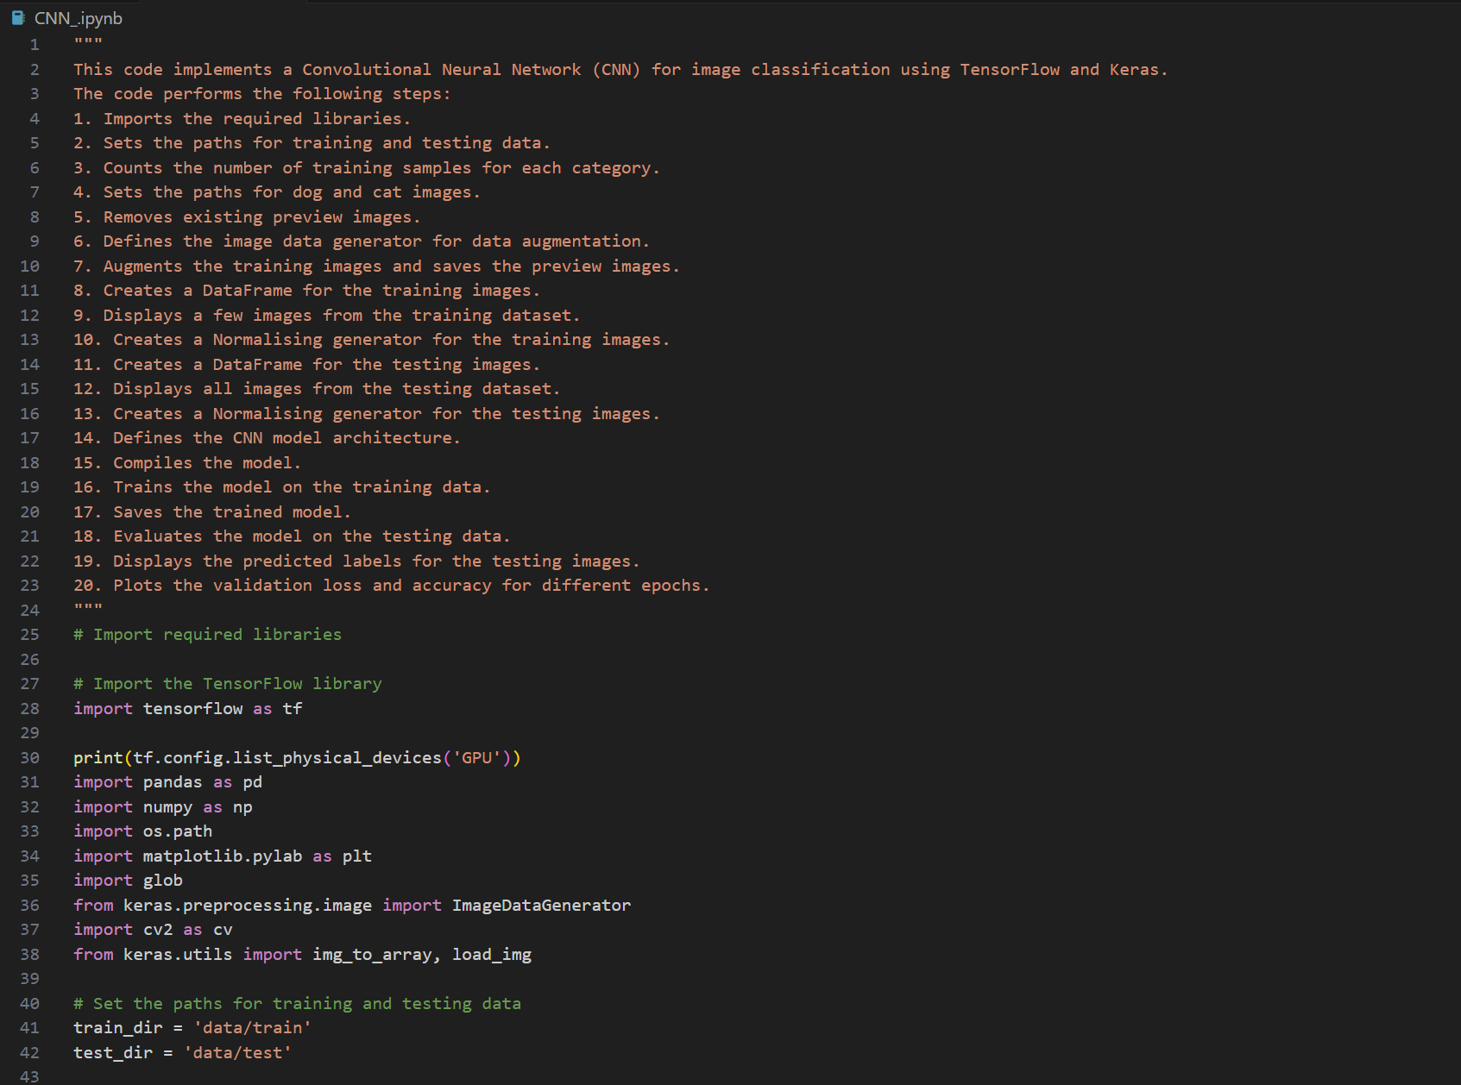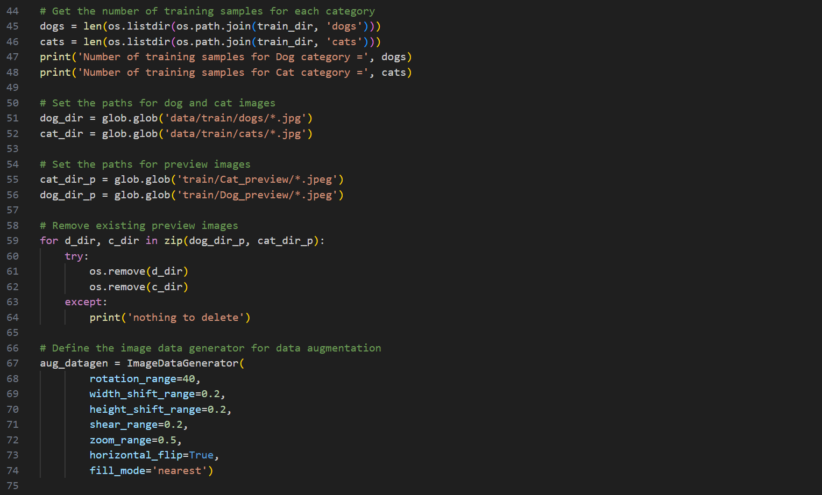 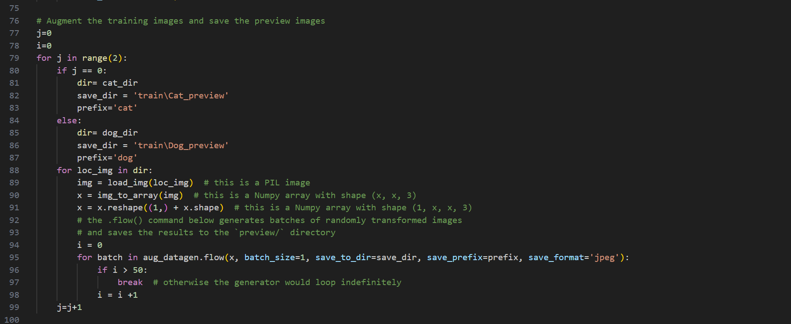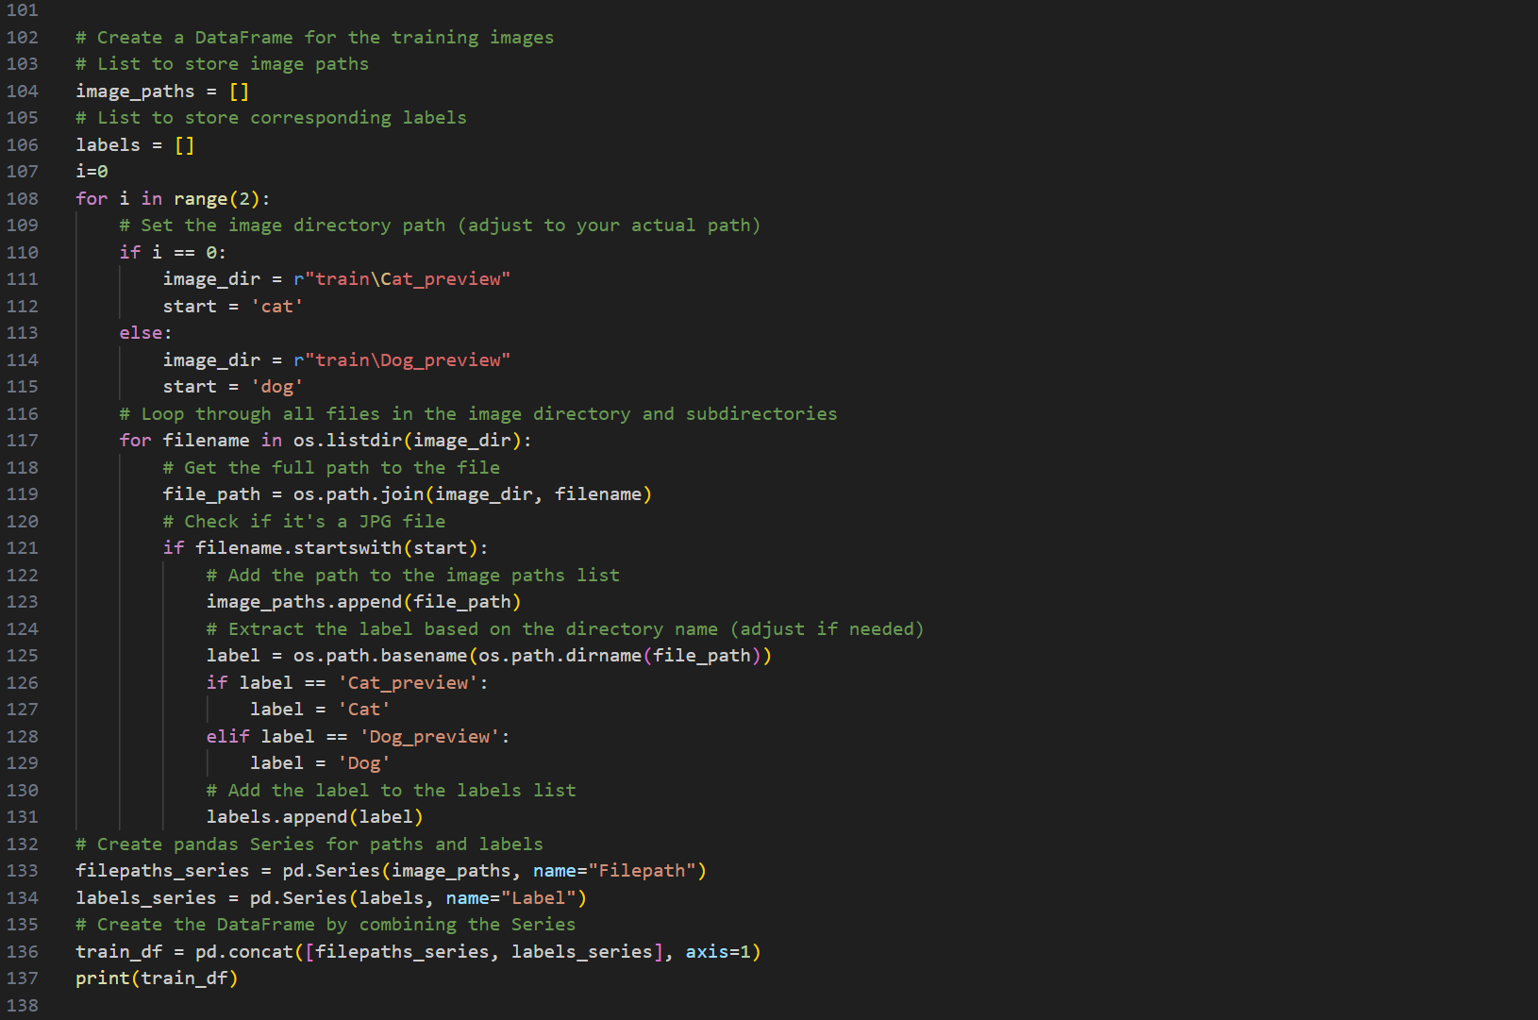 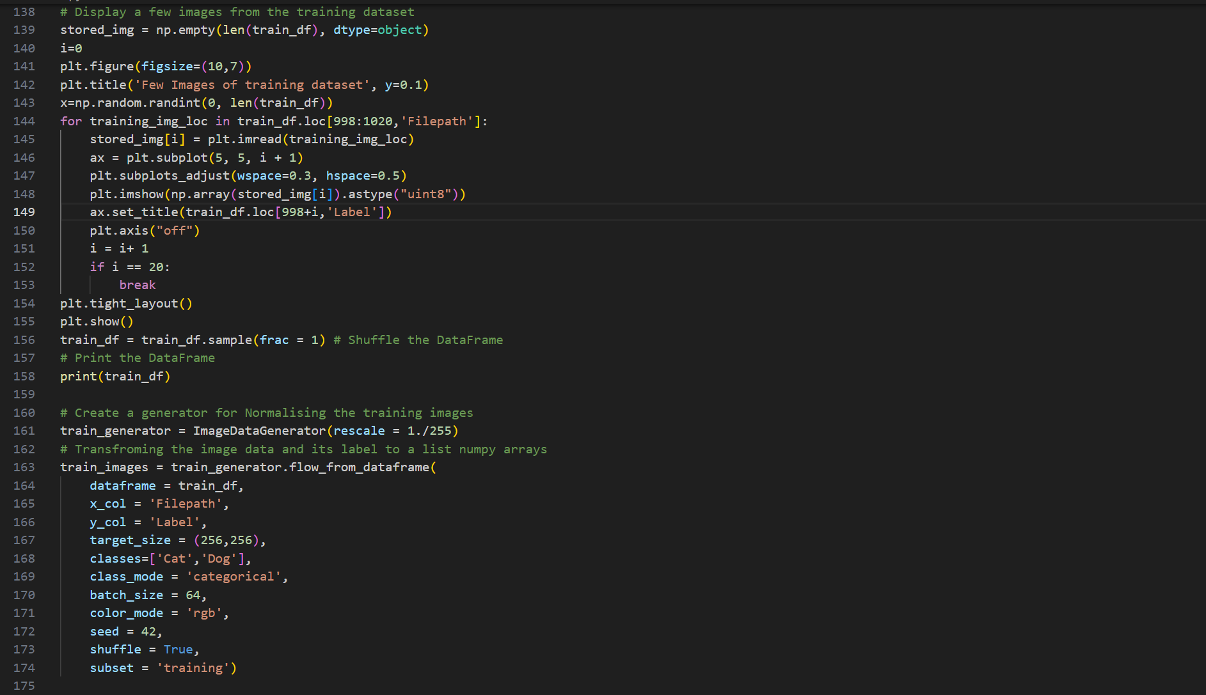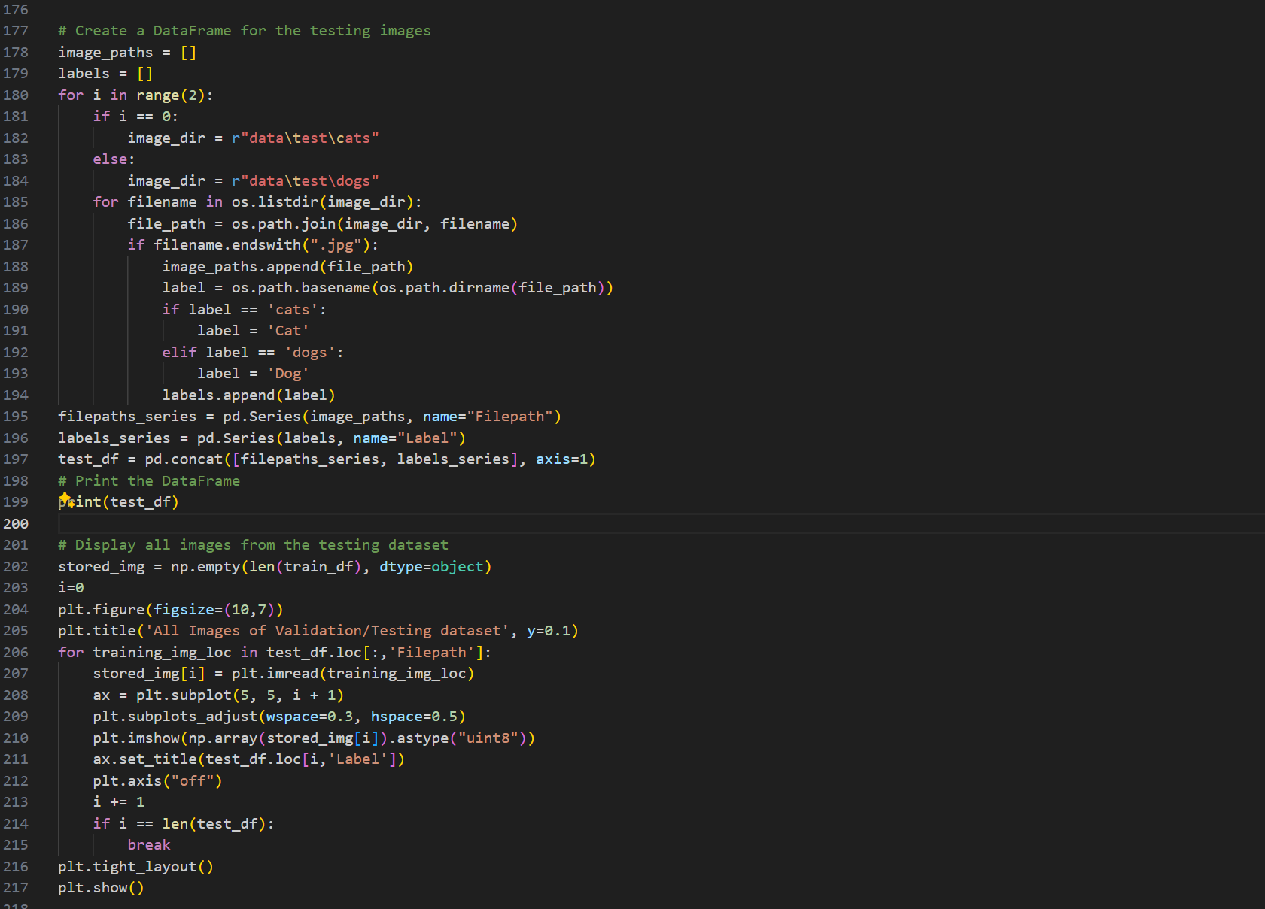 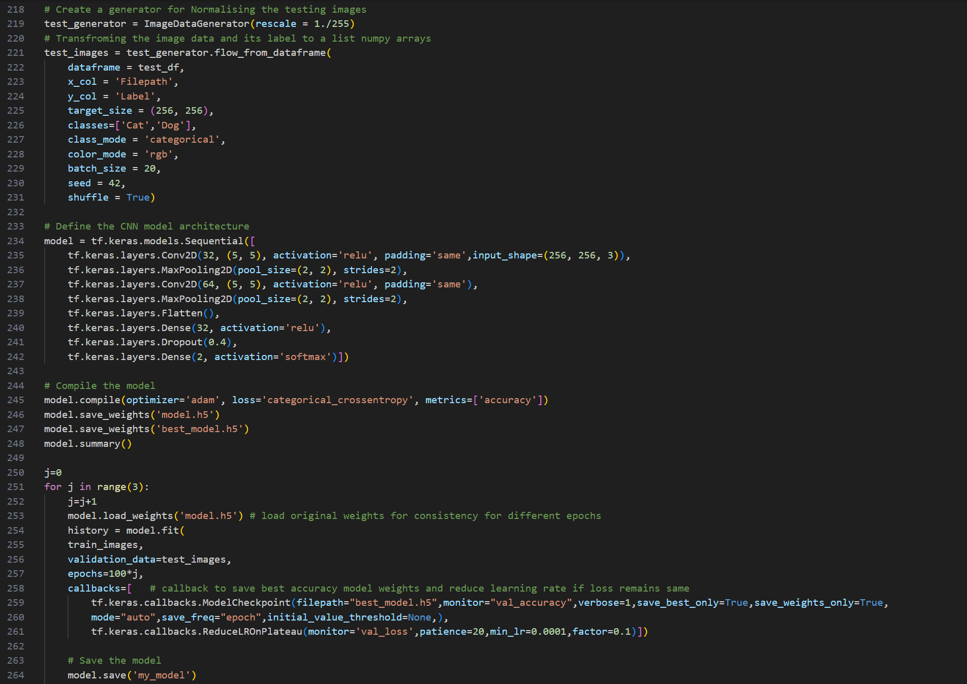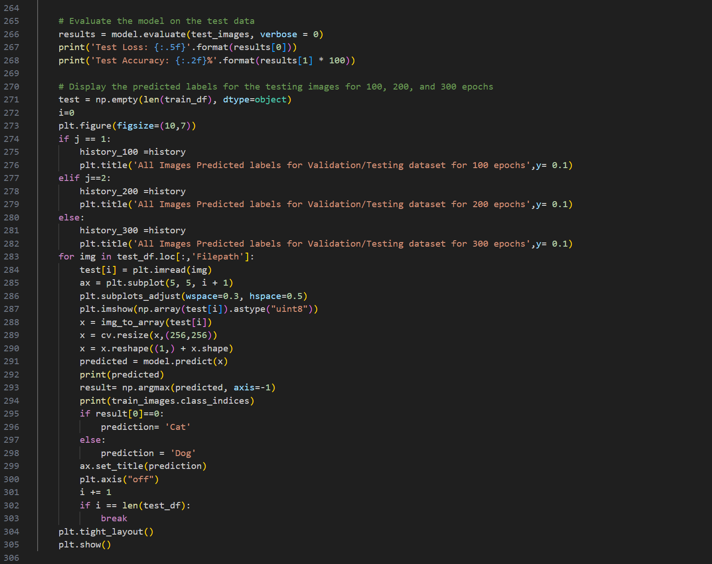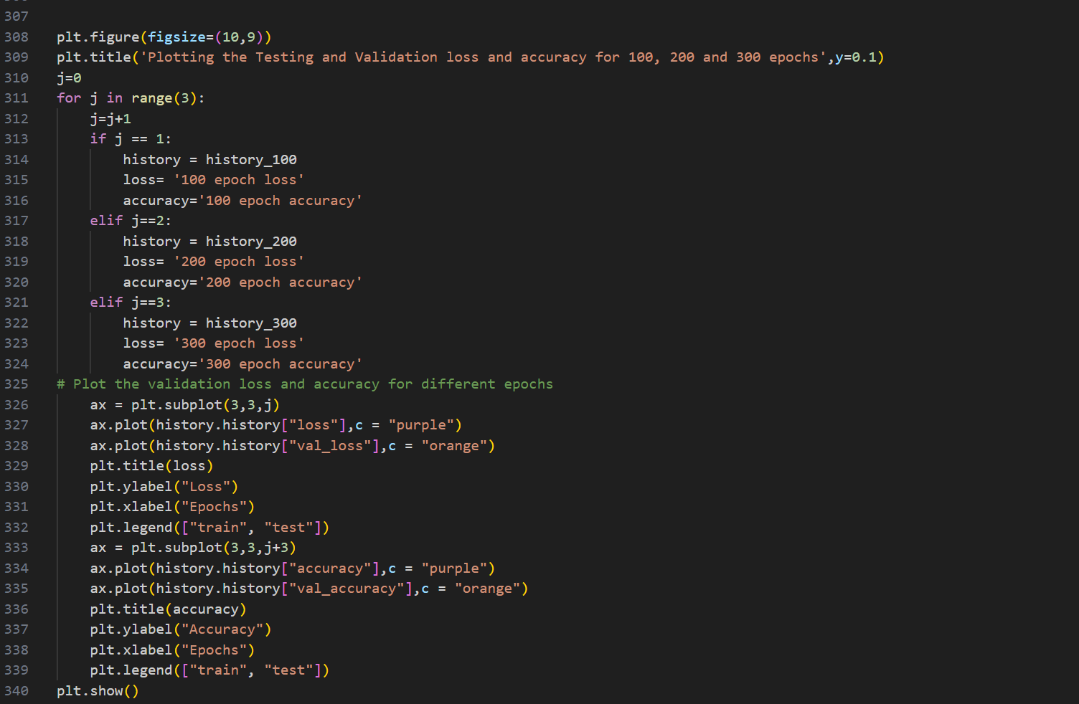

Fig. 1 CNN code using TensorFlow CNN deep learning network.

We first explore the training image dataset, which consists for two folders belonging to two categories of dog and cat. Counting the number of samples for each category (dogs and cats) provides an understanding of the dataset's distribution, which is essential for model training.

While the quality and distribution of the dataset images was decent with different images having different pixel lengths, however the quantity of images for both categories consisted of 20 image samples each. As the quantity of the dataset is extremely low for image classification problem using CNN, we must resort data augmentation techniques to increase the size of our training dataset.

Data augmentation is a technique to artificially increase the diversity of the training dataset. It involves applying various transformations to the existing images, such as rotation, shifting, and flipping, to improve the model's generalization. We will use Keras Image generaor function to generate artificial synthetic images using the original image dataset as a reference. This will increase our dataset to almost 1000 image data for each category, which will be saved under new folder as training preview. Moreover, we create a datafram using pandas that will import the locations of the new training images of both cat and dog category in a single datafram called train_df. Therefore, we can directly use this dataset for during training. Along with this we also make a test data frame for testing dataset using the original 20 image dataset of dogs and cats, without manipulating them in any form.

Next, we create image generators for training and testing image data frames that will Normalise the image depth by resizing the range of rgb colour pixels from 0 - 255 to 0 – 1, to decrease the load on the CNN model. Furthermore, we transform the image data and its corresponding label to a list numpy arrays using image generator flow function which will allow us to feed the transformed 4D array data to our CNN model. The CNN model is built as per the guidelines, utilizing Keras sequential model. The model would consist of two 2D Convolution layers for spatial convolution over images and two 2D max-pooling layer for down sampling the spatial dimensions. Additionally, it consists of Flattening layer to convert the multi-dimensional data into a one-dimensional array, that would feed our traditional Fully connected layer of 32 neurons and finally 2 neuron layer with SoftMax activation function that gives us the probability of the image being processed to belong to either the dog or cat class.

The model is compiled with the Adam optimizer, a popular choice for optimization in deep learning, and categorical Cross entropy as the loss function, suitable for binary classification problems that uses a SoftMax function as its final output layer activation function. The model is trained using the **fit** method, and the training history is stored for later visualization. Moreover, the model is made to train for consecutive 100, 200, and 300 epochs to see if there are any notable changes at the accuracy for higher training iterations. During training, the model saves the best weights that corresponds to the highest validation accuracy of the entire training epochs, and additionally also decreases the learning rate if the validation loss remains same after certain epochs. The trained model is evaluated on the testing data to assess its performance on unseen examples. This included accuracy and loss graphs of training and validation datasets and prediction on test images to identify if the image is of a dog or cat. The code displays predicted labels for testing images, providing insights into the model's predictions. The validation loss and accuracy are plotted for different epochs, helping to visualize the training process.

1. **Observations: CNN Output**

**3.1. Data Augmentation**

Data augmentation is a crucial step for preventing overfitting and improving the model's ability to generalize to new, unseen data.

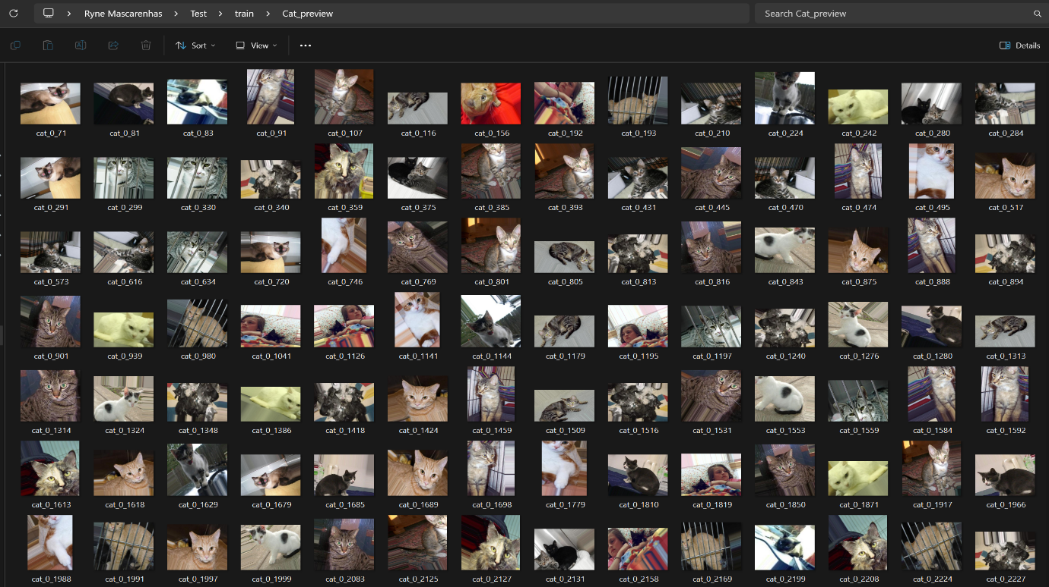

1. New cat image data folder.

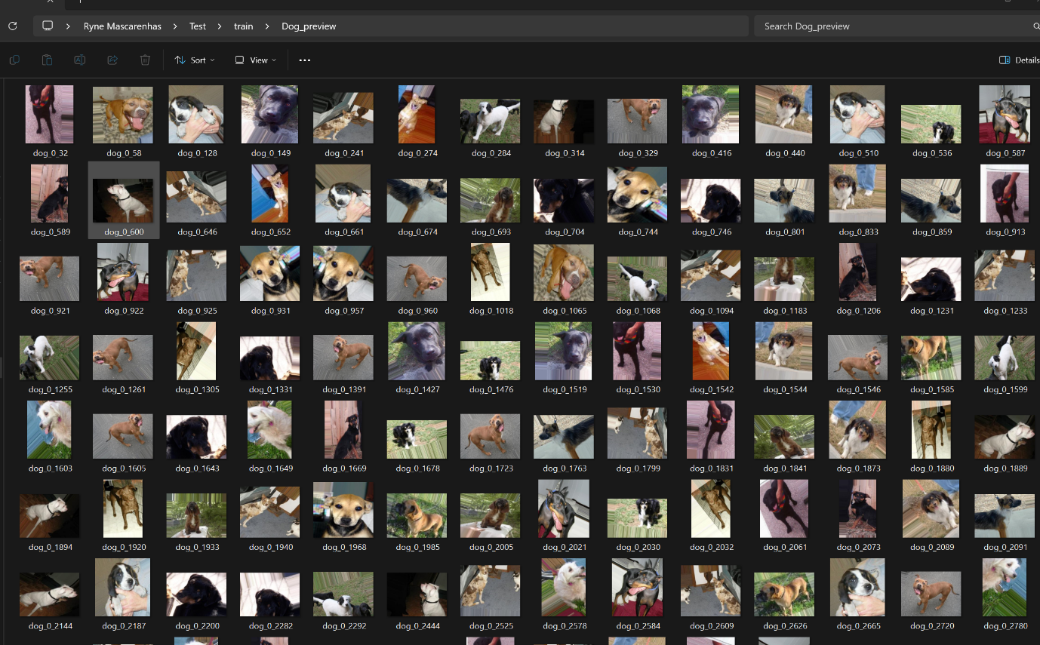

1. New dog image data folder.

Fig. 2 Augmented Images for training dataset

The created new augmented images shown in fig. 2, allows us to create data frames that can hold the location information and labels that can directly be used for training.

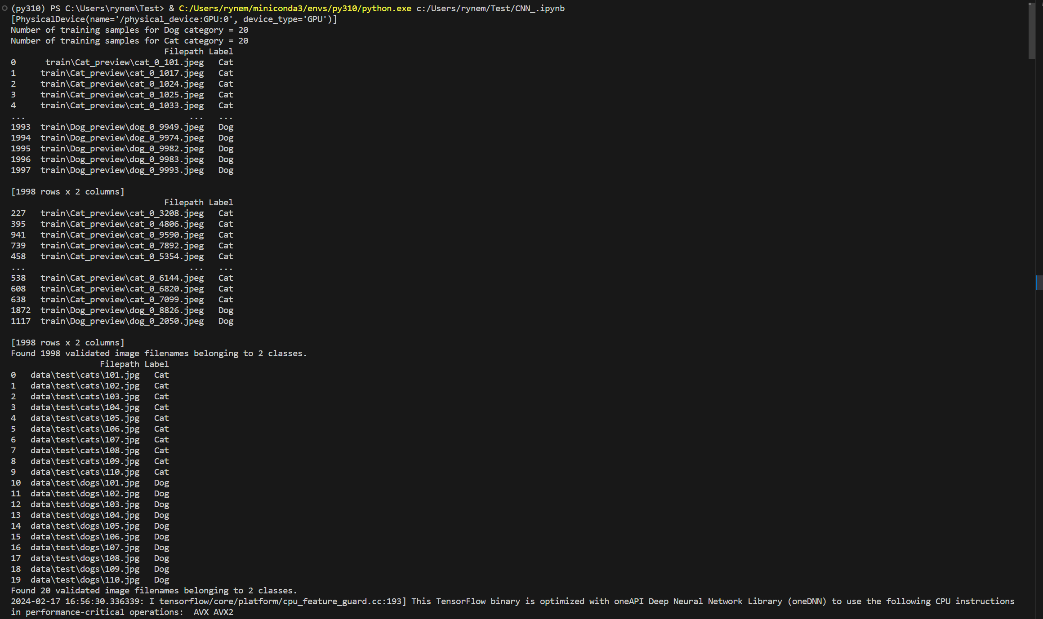

Fig. 3 Terminal output CNN code for number of original training samples, pandas data frame with augmented image data location from cat and dog, shuffled data frame, and testing data frame of cat and dog image location with their corresponding labels.

Figure 3 creates data frames that contain the locations of augmented training and original testing images, this is used to print the images as shown in fig. 4 and 5, which also allows to access the images during training.

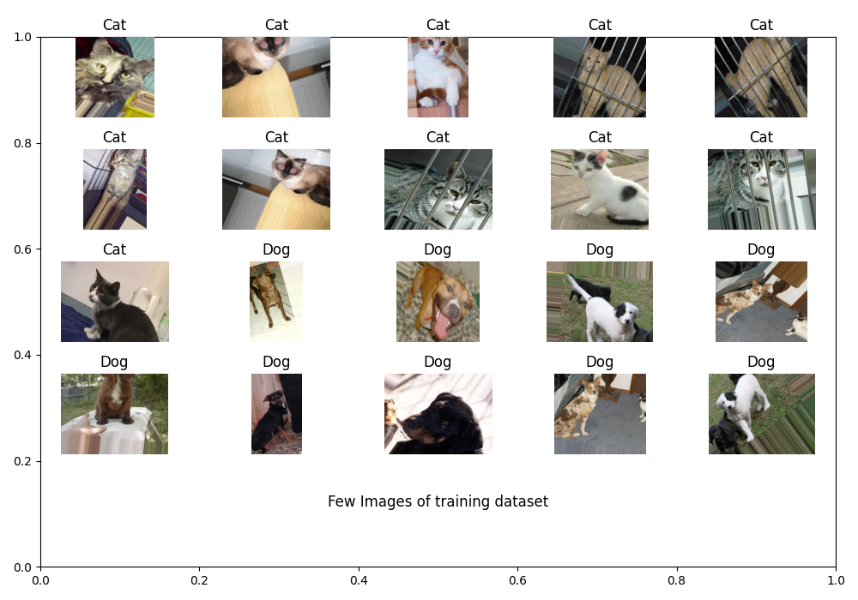

Fig. 4 Few images of new training dataset data frame.

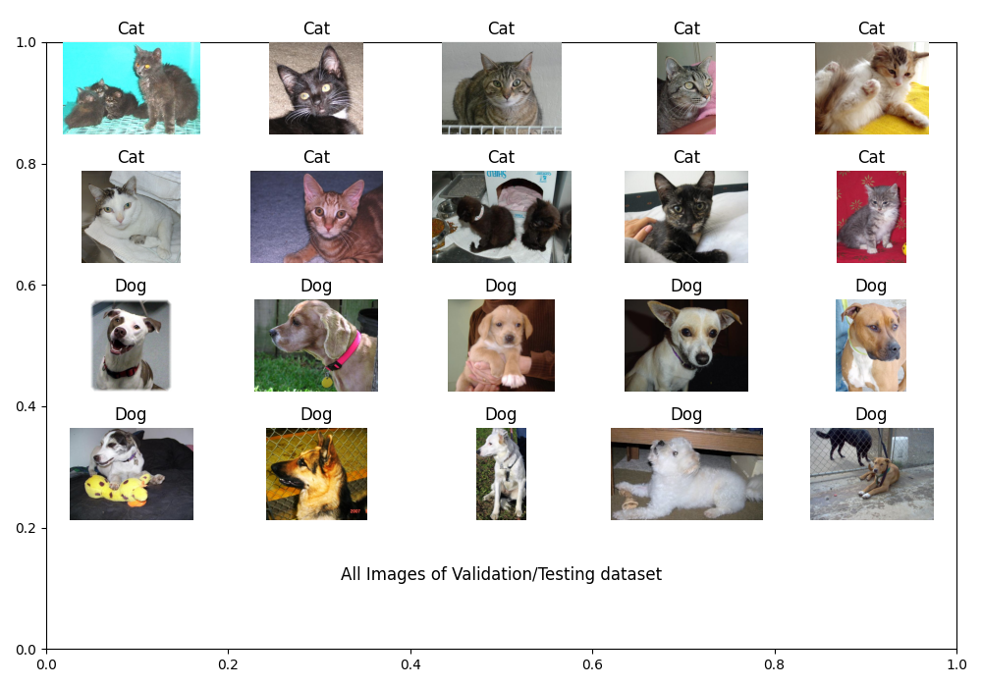

Fig. 5 All images of Testing dataset data frame.

**3.2. Model Architecture**

The chosen architecture is simple, which may limit its ability to capture complex patterns in the data. The inclusion of dropout helps reduce overfitting by randomly dropping connections during training. The figure 6 shows the created CNN architecture with chosen input shape of (1,256,256,3). This architecture creates total 8,442,402 trainable parameters.

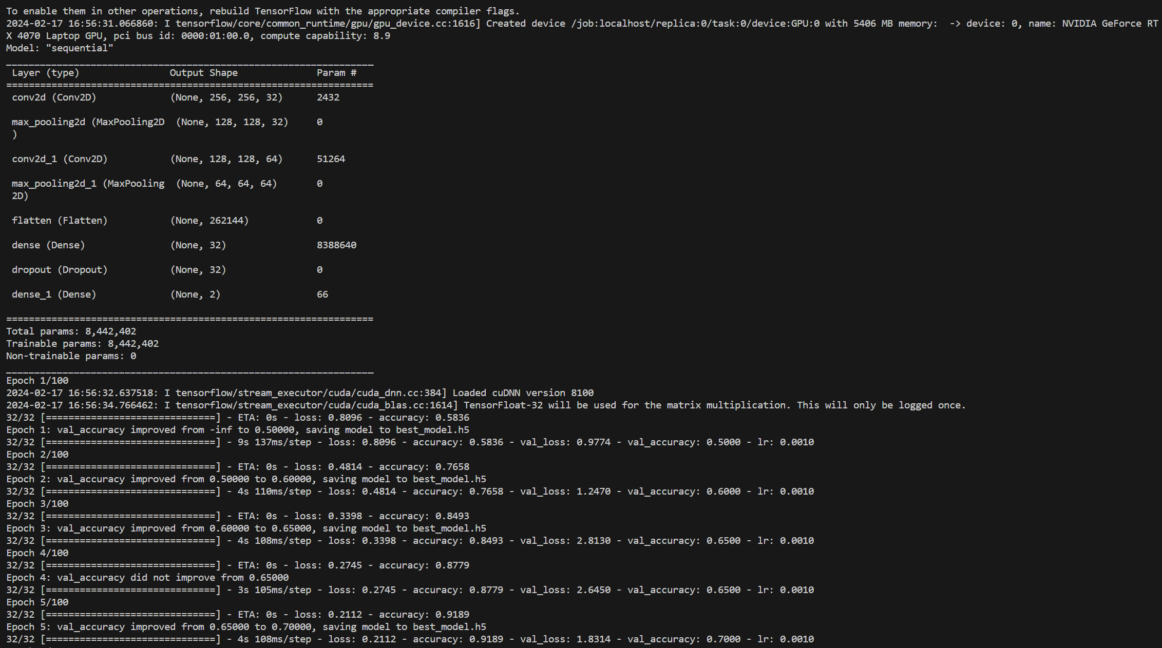

Fig. 6 Model architecture as per the guidelines.

**3.3. Training and Evaluation**

The model is trained over multiple epochs, and the training history is saved to observe the convergence and potential overfitting. Evaluation on the test set provides insights into the model's generalization performance. We have created three different trained models with same architecture and parameters, while training them for different epochs. This is show in the following figures, along with the total model loss and accuracy.

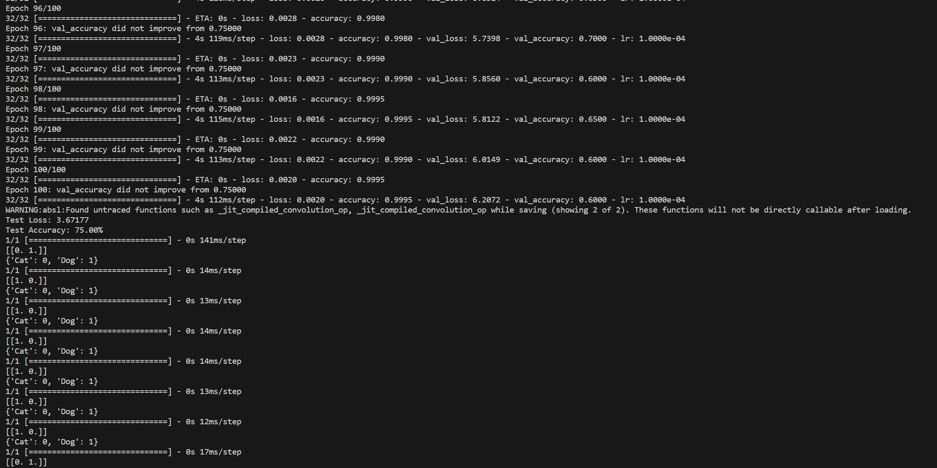

1. For 100 epoch trained model.

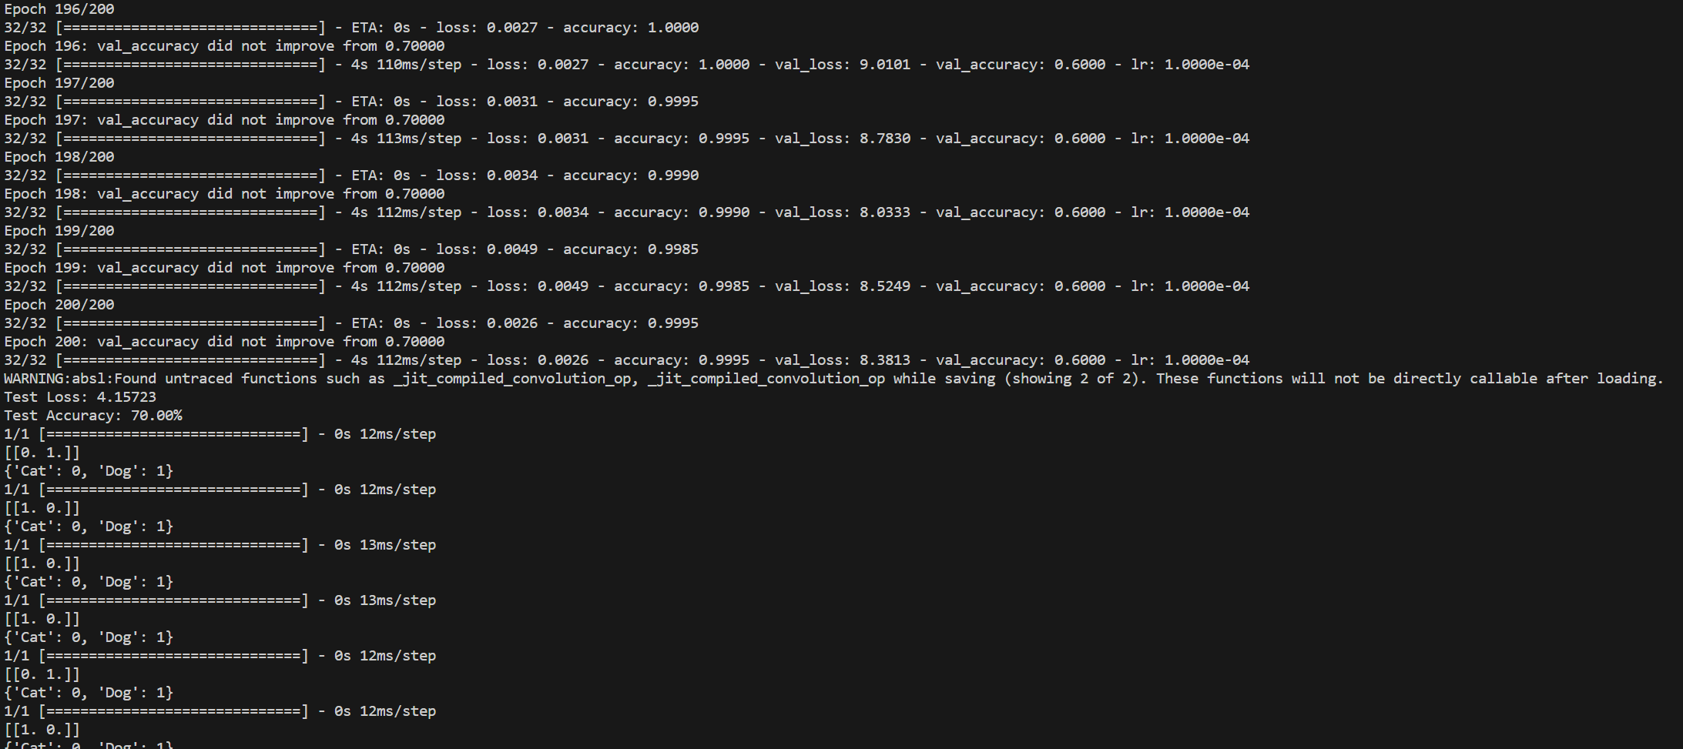

1. For 200 epoch trained model.

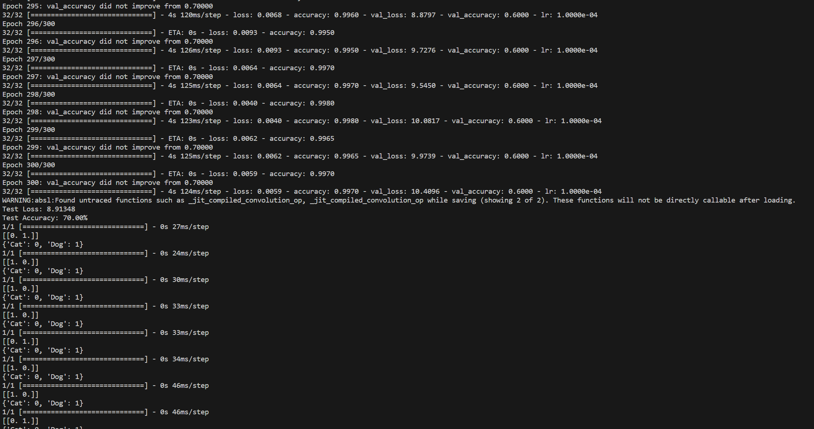

1. For 300 epoch trained model.

Fig. 7 Total model loss and accuracy for different trained models.

The model shows that there is no improvement in the model for training the same model for a greater number of epochs, as figure 7 clearly shows that for 200 and 300 epochs the model accuracy decreases.

**3.4. Predictions**

Predicted labels for testing images are displayed, allowing a qualitative assessment of the model's performance. We have created three different models with same architecture and parameters, while training them for different epochs. Figure 8 shows that there is different label prediction for the training dataset, as for 100, 200 and 300 epochs the prediction are correct for 15, 13, and 14 respectively out of 20 training sample data images. This clearly shows that increasing training epochs for more training doesn’t yield higher accuracy.

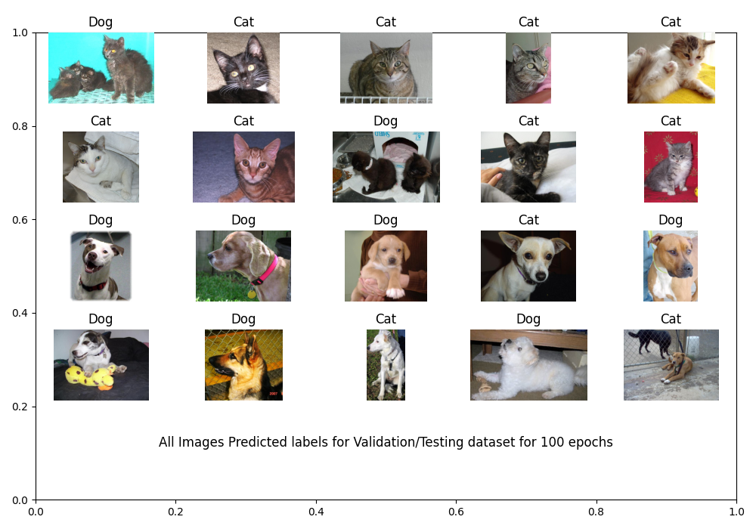

1. For 100 epochs.

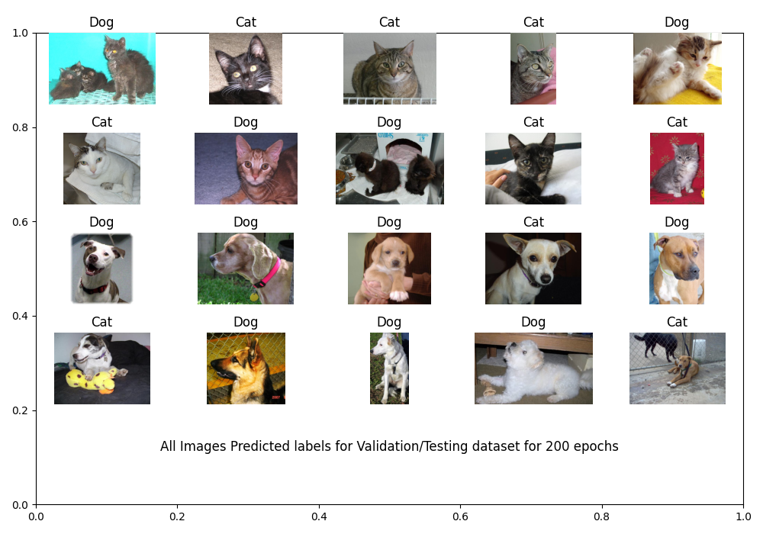

1. For 200 epochs.

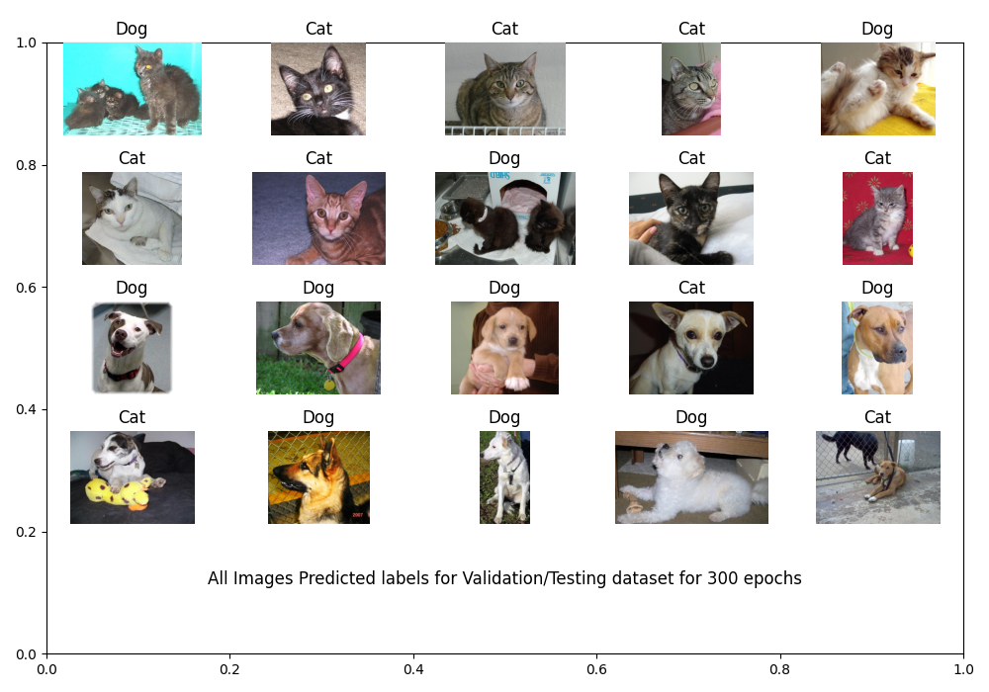

1. For 300 epochs.

Fig. 8 All prediction labels for testing images for different models.

**3.5. Visualization:**

The plots of validation loss and accuracy across epochs help to understand the training dynamics and identify potential issues like overfitting or underfitting. The Figure 9 shows us training data loss decreasing and accuracy increasing for all different models trained. However, the validation loss for all the models increasing and validation accuracy fluctuating and settling at 75% most of the time. As the trend remains the same over different model trained at different epochs, this points clearly as sign of overfitting.

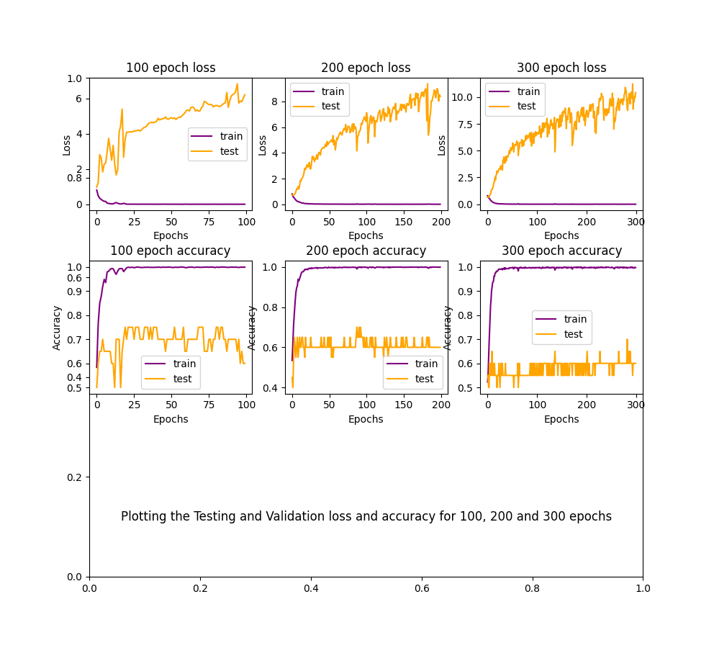

Fig. 9 Plotting Training and Testing loss and accuracy for 100, 200, and 300 epoch models.

1. **Conclusion:**

The provided code successfully implements a basic image classification pipeline using a CNN. With some refinements and adjustments, it has the potential to be a robust solution for the task at hand. The given architecture and training dataset restricts the model to overcome overfitting issues even after implementing data augmentation. Fortunately, all the models can predict more than 60% of time the image label correctly. Additionally, the subsequent models after 100 epoch model show decrease in accuracy and increase in loss of testing dataset.

* 1. **Recommendations**

The model can improve with continued experimentation and optimization are for different CNN architecture with more dropout layers for further improvements, and along with a more diverse dataset of at least 100 different types of dogs and cat samples.

Top of Form